LAB 8
Bài tập 1.1 KIỂM THỬ TIÊU ĐỀ TRANG WEB (1.0 điểm)
package dtm;

import org.openqa.selenium.By;
import org.openqa.selenium.WebDriver;
import org.openqa.selenium.WebElement;
import org.openqa.selenium.chrome.ChromeDriver;
import org.testng.Assert;
import org.testng.annotations.AfterMethod;
import org.testng.annotations.BeforeMethod;
import org.testng.annotations.Test;

import io.github.bonigarcia.wdm.WebDriverManager;

public class TitleTest {

WebDriver driver;

@BeforeMethod
public void setUp() {
WebDriverManager.chromedriver().setup();
driver = new ChromeDriver();
driver.manage().window().maximize();
driver.get("https://www.saucedemo.com");
}

@Test(description = "Kiem thu tieu de trang chu")
public void testTitle() {
String expectedTitle = "Swag Labs";
String actualTitle = driver.getTitle();
Assert.assertEquals(actualTitle, expectedTitle, "Tieu de trang khong dung!");
}

@Test(description = "Kiem thu URL trang chu")
public void testURL() {
String actualUrl = driver.getCurrentUrl();
Assert.assertTrue(actualUrl.contains("saucedemo"), "URL khong hop le!");
}

@Test(description = "Kiem thu noi dung page source")
public void testPageSource() {
String pageSource = driver.getPageSource();
Assert.assertTrue(pageSource.contains("Swag Labs"), "Page source khong chua noi dung mong doi!");
}

@Test(description = "Kiem tra form dang nhap co hien thi")
public void testLoginFormDisplay() {
WebElement username = driver.findElement(By.id("user-name"));
WebElement password = driver.findElement(By.id("password"));
WebElement loginButton = driver.findElement(By.id("login-button"));

Assert.assertTrue(username.isDisplayed(), "Username khong hien thi!");
Assert.assertTrue(password.isDisplayed(), "Password khong hien thi!");
Assert.assertTrue(loginButton.isDisplayed(), "Nut Login khong hien thi!");
}

@AfterMethod
public void tearDown() {
if (driver != null) {
driver.quit();
}
}
}

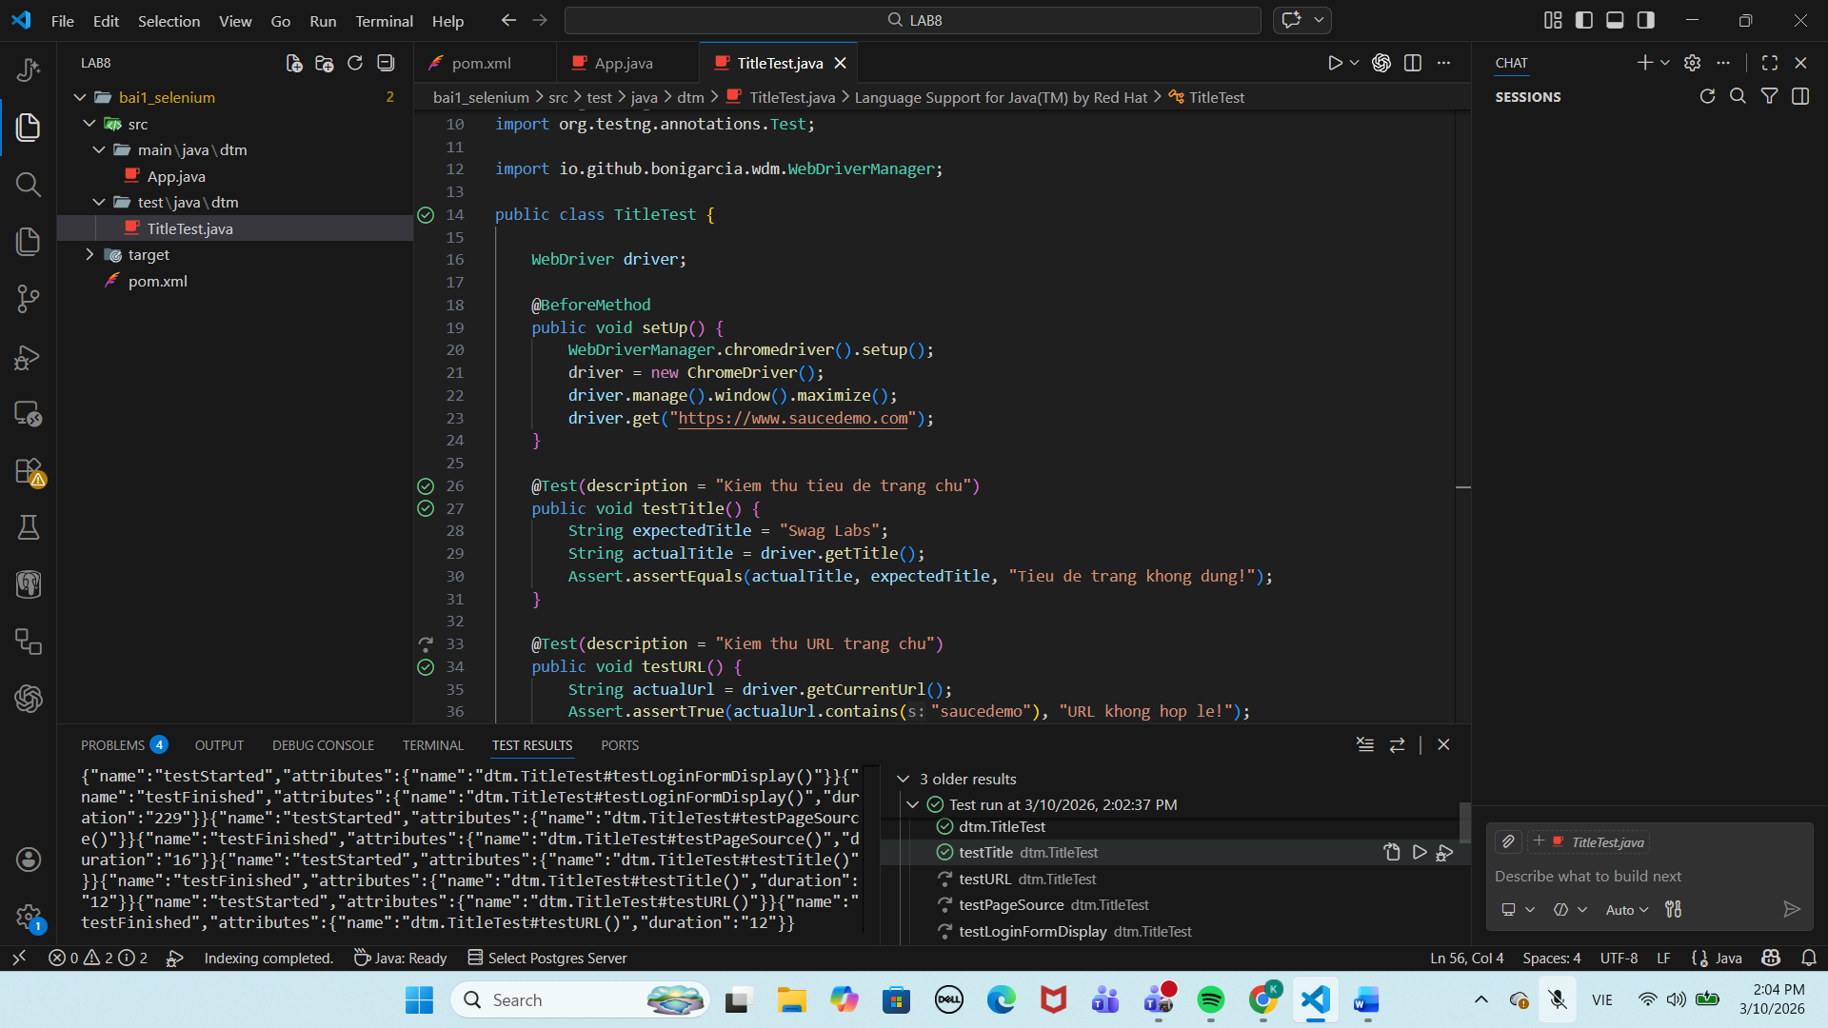
Bài tập 1.2: KIỂM THỬ FORM ĐĂNG NHẬP (1.0 điểm)
package dtm;

import io.github.bonigarcia.wdm.WebDriverManager;
import org.openqa.selenium.By;
import org.openqa.selenium.WebDriver;
import org.openqa.selenium.WebElement;
import org.openqa.selenium.chrome.ChromeDriver;
import org.openqa.selenium.support.ui.ExpectedConditions;
import org.openqa.selenium.support.ui.WebDriverWait;
import org.testng.Assert;
import org.testng.annotations.AfterMethod;
import org.testng.annotations.BeforeMethod;
import org.testng.annotations.Test;

import java.time.Duration;

public class LoginTest {

WebDriver driver;
WebDriverWait wait;

@BeforeMethod
public void setUp() {
WebDriverManager.chromedriver().setup();
driver = new ChromeDriver();
driver.manage().window().maximize();
driver.get("https://www.saucedemo.com");
wait = new WebDriverWait(driver, Duration.ofSeconds(10));
}

@Test(description = "Dang nhap thanh cong voi tai khoan hop le")
public void testLoginSuccess() {
driver.findElement(By.id("user-name")).sendKeys("standard_user");
driver.findElement(By.id("password")).sendKeys("secret_sauce");
driver.findElement(By.id("login-button")).click();

wait.until(ExpectedConditions.urlContains("inventory.html"));
String actualUrl = driver.getCurrentUrl();

Assert.assertTrue(
actualUrl.contains("inventory.html"),
"Dang nhap thanh cong nhung khong chuyen den trang inventory.html"
);
}

@Test(description = "Dang nhap sai mat khau")
public void testLoginWrongPassword() {
driver.findElement(By.id("user-name")).sendKeys("standard_user");
driver.findElement(By.id("password")).sendKeys("sai_mat_khau");
driver.findElement(By.id("login-button")).click();

WebElement errorMessage = wait.until(
ExpectedConditions.visibilityOfElementLocated(By.cssSelector("h3[data-test='error']"))
);

String actualError = errorMessage.getText();
String expectedError = "Epic sadface: Username and password do not match any user in this service";

Assert.assertEquals(
actualError,
expectedError,
"Thong bao loi khi nhap sai mat khau khong dung"
);
}

@Test(description = "Bo trong username")
public void testLoginEmptyUsername() {
driver.findElement(By.id("password")).sendKeys("secret_sauce");
driver.findElement(By.id("login-button")).click();

WebElement errorMessage = wait.until(
ExpectedConditions.visibilityOfElementLocated(By.cssSelector("h3[data-test='error']"))
);

String actualError = errorMessage.getText();
String expectedError = "Epic sadface: Username is required";

Assert.assertEquals(
actualError,
expectedError,
"Thong bao loi khi bo trong username khong dung"
);
}

@Test(description = "Bo trong password")
public void testLoginEmptyPassword() {
driver.findElement(By.id("user-name")).sendKeys("standard_user");
driver.findElement(By.id("login-button")).click();

WebElement errorMessage = wait.until(
ExpectedConditions.visibilityOfElementLocated(By.cssSelector("h3[data-test='error']"))
);

String actualError = errorMessage.getText();
String expectedError = "Epic sadface: Password is required";

Assert.assertEquals(
actualError,
expectedError,
"Thong bao loi khi bo trong password khong dung"
);
}

@Test(description = "Dang nhap voi locked_out_user")
public void testLoginLockedUser() {
driver.findElement(By.id("user-name")).sendKeys("locked_out_user");
driver.findElement(By.id("password")).sendKeys("secret_sauce");
driver.findElement(By.id("login-button")).click();

WebElement errorMessage = wait.until(
ExpectedConditions.visibilityOfElementLocated(By.cssSelector("h3[data-test='error']"))
);

String actualError = errorMessage.getText();
String expectedError = "Epic sadface: Sorry, this user has been locked out.";

Assert.assertEquals(
actualError,
expectedError,
"Thong bao loi cua tai khoan bi khoa khong dung"
);
}

@AfterMethod
public void tearDown() {
if (driver != null) {
driver.quit();
}
}
}

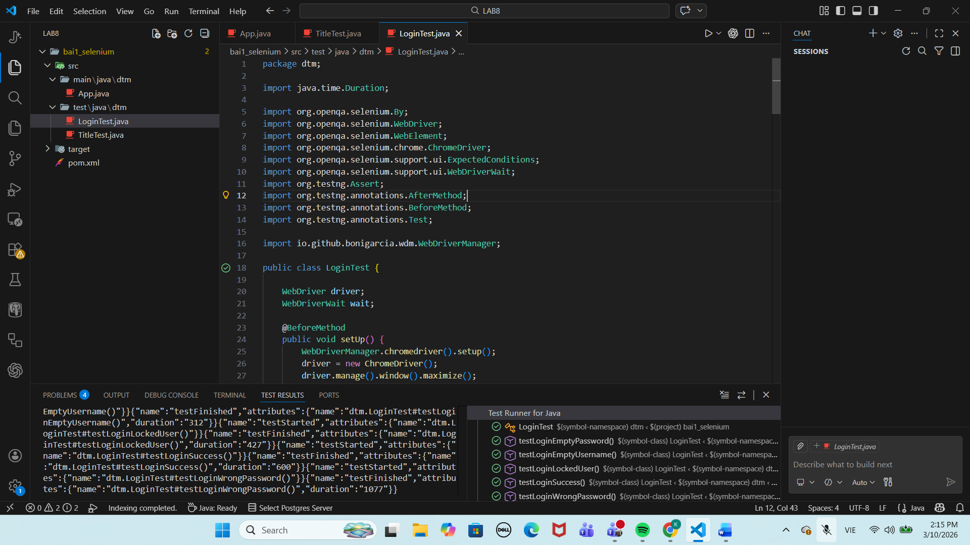

Bài tập 2.1 XÂY DỰNG TESTNG SUITE XML (1.0 điểm)
LoginTest.java
package dtm;

import org.testng.Assert;
import org.testng.annotations.Test;

public class LoginTest {

@Test(groups = {"smoke", "regression"})
public void testLoginSuccess() {
System.out.println("LoginTest - testLoginSuccess");
Assert.assertTrue(true, "Dang nhap hop le that bai");
}

@Test(groups = {"regression"})
public void testLoginWrongPassword() {
System.out.println("LoginTest - testLoginWrongPassword");
Assert.assertTrue(true, "Dang nhap sai mat khau khong hien thong bao loi");
}
}

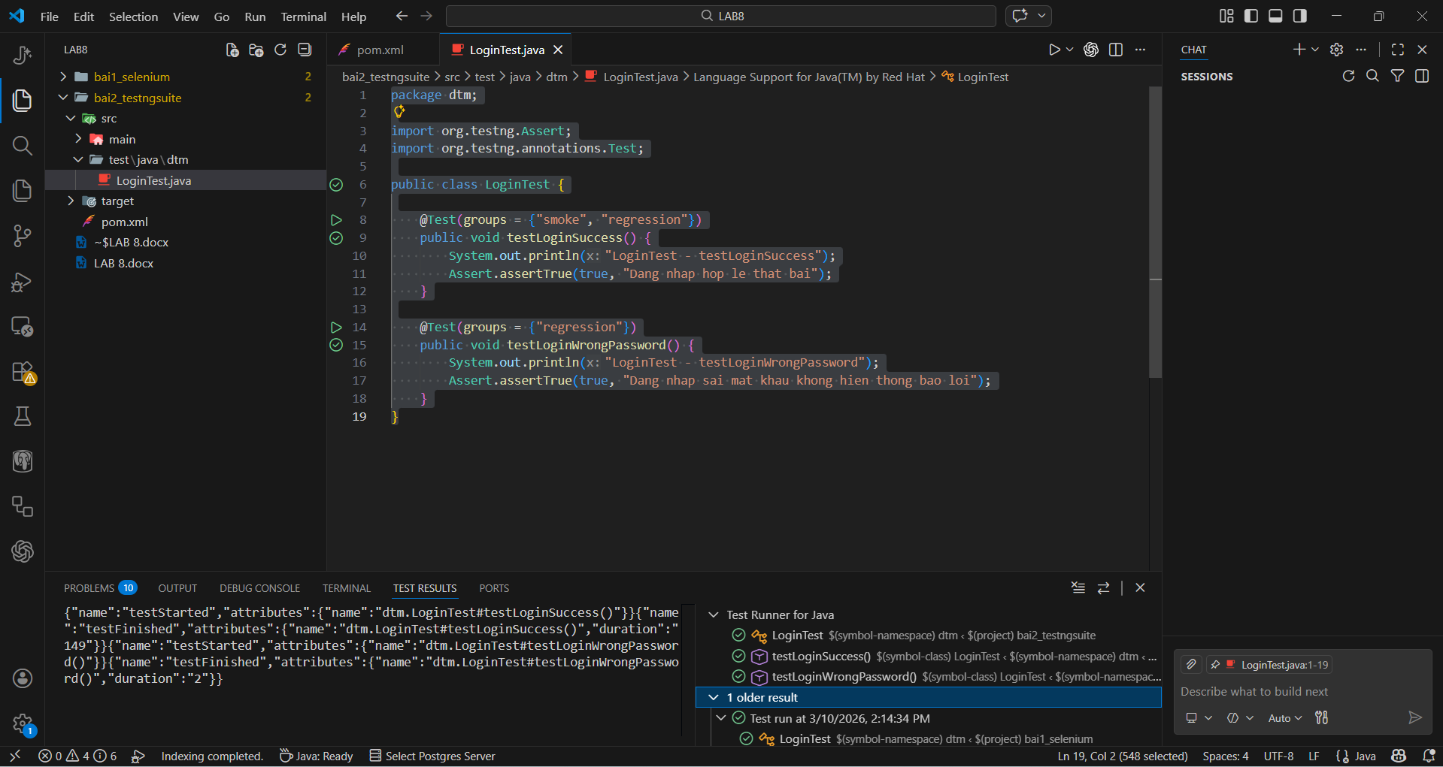

CartTest.java
package dtm;

import org.testng.Assert;
import org.testng.annotations.Test;

public class CartTest {

@Test(groups = {"smoke", "regression"})
public void testAddToCart() {
System.out.println("CartTest - testAddToCart");
Assert.assertTrue(true, "Them vao gio hang that bai");
}

@Test(groups = {"regression"})
public void testRemoveFromCart() {
System.out.println("CartTest - testRemoveFromCart");
Assert.assertTrue(true, "Xoa khoi gio hang that bai");
}
}

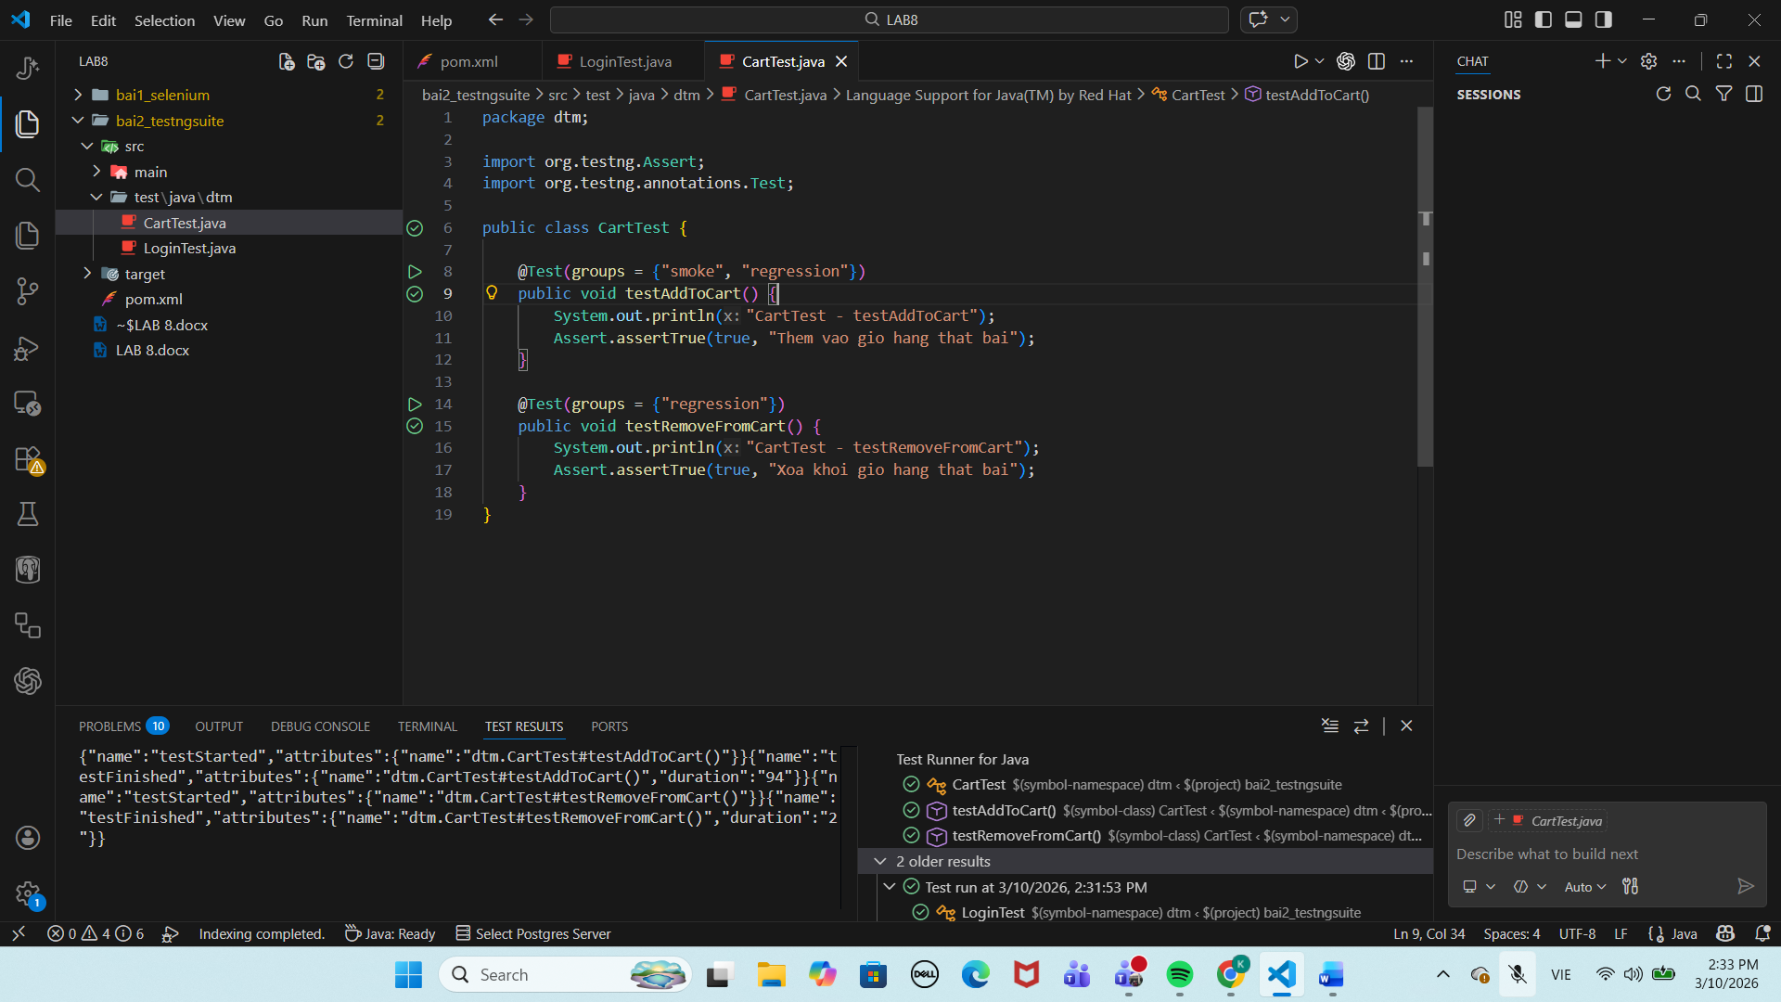

CheckoutTest.java
package dtm;

import org.testng.Assert;
import org.testng.annotations.Test;

public class CheckoutTest {

@Test(groups = {"smoke", "regression"})
public void testCheckoutOverview() {
System.out.println("CheckoutTest - testCheckoutOverview");
Assert.assertTrue(true, "Khong mo duoc trang checkout overview");
}

@Test(groups = {"regression"})
public void testCheckoutComplete() {
System.out.println("CheckoutTest - testCheckoutComplete");
Assert.assertTrue(true, "Checkout complete that bai");
}
}

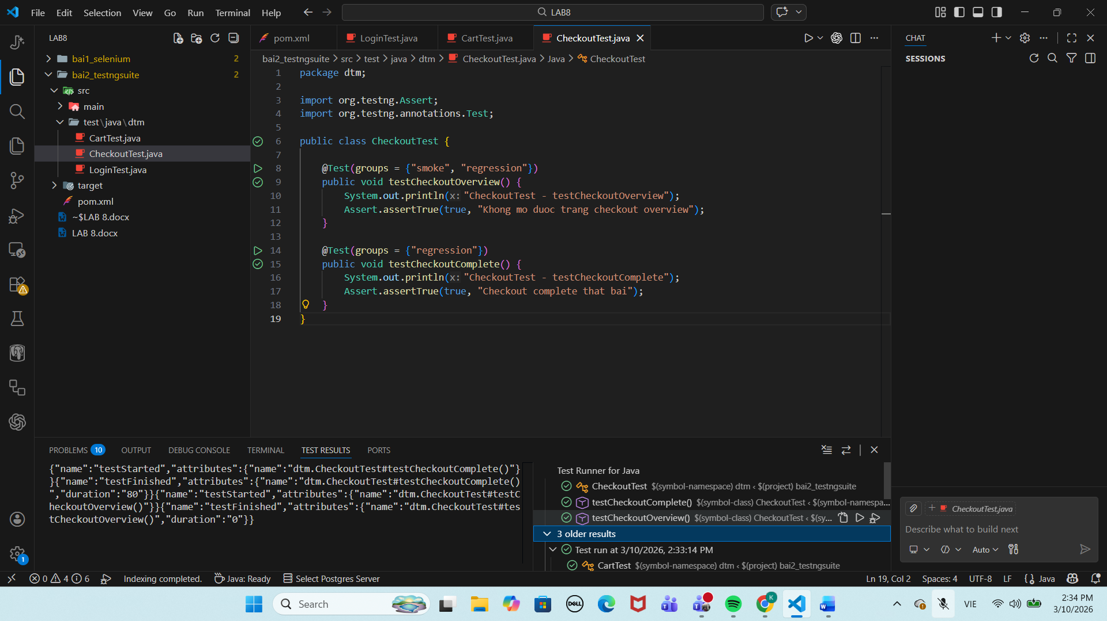

Bài tập 2.2 PARALLEL EXECUTION VỚI THREADLOCAL (1.0 điểm)
testng.xml:
<!DOCTYPE suite SYSTEM "https://testng.org/testng-1.0.dtd">
<suite name="Parallel Suite" parallel="classes" thread-count="2">

<parameter name="browser" value="chrome"/>

<test name="Parallel Login and Cart Test">
<classes>
<class name="dtm.LoginTest"/>
<class name="dtm.CartTest"/>
</classes>
</test>

</suite>

LoginTest:
package dtm;

import org.openqa.selenium.By;
import org.openqa.selenium.WebDriver;
import org.testng.Assert;
import org.testng.annotations.Test;

public class LoginTest extends BaseTest {

@Test
public void testLoginSuccess() throws InterruptedException {
WebDriver driver = DriverFactory.getDriver();

System.out.println("LoginTest chạy trên thread: " + Thread.currentThread().getId());

driver.get("https://www.saucedemo.com");
driver.findElement(By.id("user-name")).sendKeys("standard_user");
driver.findElement(By.id("password")).sendKeys("secret_sauce");
driver.findElement(By.id("login-button")).click();

Thread.sleep(3000); // chỉ để dễ nhìn 2 cửa sổ cùng mở khi demo
Assert.assertTrue(driver.getCurrentUrl().contains("inventory"),
"Dang nhap thanh cong nhung khong chuyen den inventory");
}

@Test
public void testLoginPageTitle() throws InterruptedException {
WebDriver driver = DriverFactory.getDriver();

System.out.println("LoginTest - testLoginPageTitle chạy trên thread: " + Thread.currentThread().getId());

driver.get("https://www.saucedemo.com");
Thread.sleep(3000); // để dễ quan sát khi chụp màn hình

Assert.assertEquals(driver.getTitle(), "Swag Labs",
"Tieu de trang dang nhap khong dung");
}
}

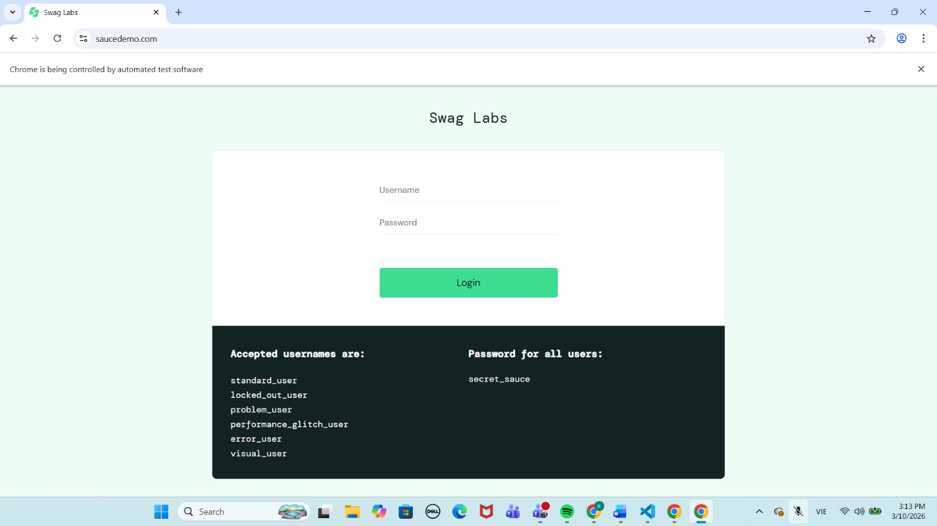
CartTest:
package dtm;

import org.openqa.selenium.By;
import org.openqa.selenium.WebDriver;
import org.testng.Assert;
import org.testng.annotations.Test;

public class CartTest extends BaseTest {

@Test
public void testAddToCart() throws InterruptedException {
WebDriver driver = DriverFactory.getDriver();

System.out.println("CartTest chạy trên thread: " + Thread.currentThread().getId());

driver.get("https://www.saucedemo.com");
driver.findElement(By.id("user-name")).sendKeys("standard_user");
driver.findElement(By.id("password")).sendKeys("secret_sauce");
driver.findElement(By.id("login-button")).click();

driver.findElement(By.id("add-to-cart-sauce-labs-backpack")).click();

Thread.sleep(3000); // để dễ nhìn 2 cửa sổ cùng mở
String cartBadge = driver.findElement(By.className("shopping_cart_badge")).getText();

Assert.assertEquals(cartBadge, "1",
"So luong san pham trong gio hang khong dung");
}

@Test
public void testCartIconDisplay() throws InterruptedException {
WebDriver driver = DriverFactory.getDriver();

System.out.println("CartTest - testCartIconDisplay chạy trên thread: " + Thread.currentThread().getId());

driver.get("https://www.saucedemo.com");
driver.findElement(By.id("user-name")).sendKeys("standard_user");
driver.findElement(By.id("password")).sendKeys("secret_sauce");
driver.findElement(By.id("login-button")).click();

Thread.sleep(3000); // để dễ quan sát
Assert.assertTrue(driver.findElement(By.id("shopping_cart_container")).isDisplayed(),
"Icon gio hang khong hien thi");
}
}

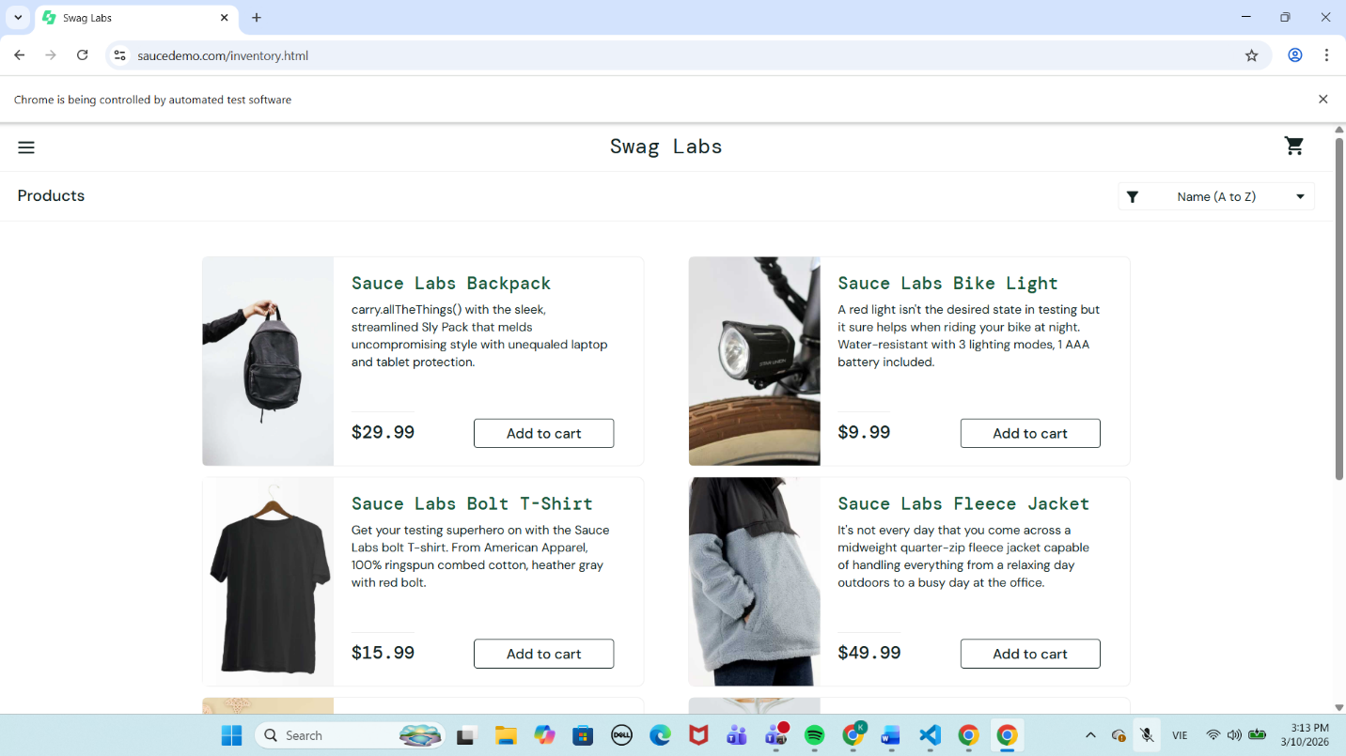
Bài tập 3.1 PHÂN TÍCH CFG VÀ TÍNH TOÁN COVERAGE (1.0 điểm)
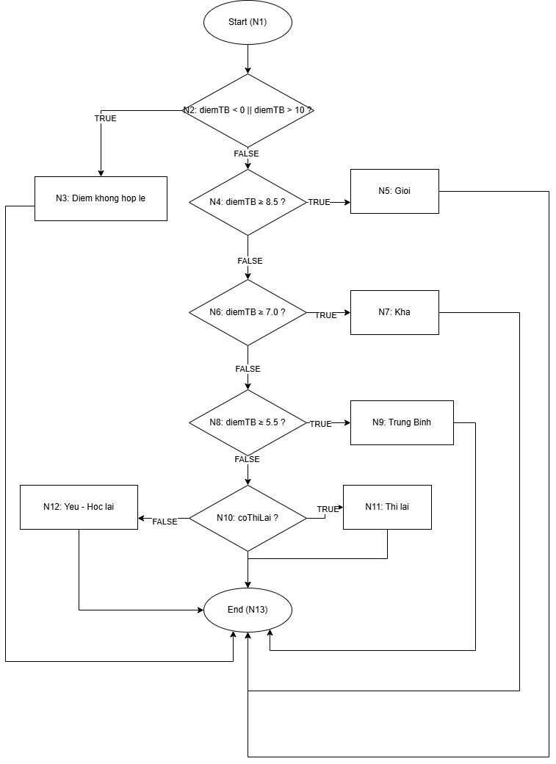
Test case tối thiểu để đạt 100% Statement Coverage
TC | diemTB | coThiLai | Kết quả mong đợi
SC1 | -1 | false | Diem khong hop le
SC2 | 9 | false | Gioi
SC3 | 7 | false | Kha
SC4 | 6 | false | Trung Binh
SC5 | 4 | true | Thi lai
SC6 | 4 | false | Yeu - Hoc lai

Test case tối thiểu để đạt 100% Branch Coverage
TC | diemTB | coThiLai | Kết quả mong đợi
BC1 | -1 | false | Diem khong hop le
BC2 | 9 | false | Gioi
BC3 | 7 | false | Kha
BC4 | 6 | false | Trung Binh
BC5 | 4 | true | Thi lai
BC6 | 4 | false | Yeu - Hoc lai

